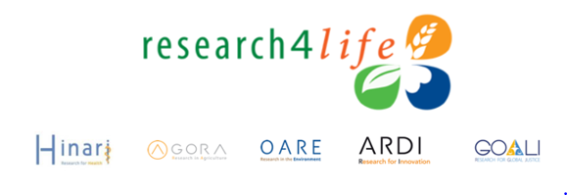
Below you can find a list of additional websites offering resources for librarians and researchers.
AuthorAID: is a free international research community sponsored by INASP. The goal is to help researchers in developing countries to publish and communicate their work. Key sections include Resources with numerous documents (500+) and presentations on ‘best practices’ in writing and publication and Mentoring & Collaboration with researchers and professional editors. The site also contains a Discussion Forum.

BMJ: Topics include How to submit an article for publication plus a discussion of the Publication procedure, including the peer review process, editorial policies and the BMJ style - as the resources are geared toward submission to one publisher’s journals.

Elsevier Researcher Academy: Is a free e-learning platform designed to unlock the potential of early and mid-career researchers. Specific sections focus on How to obtain funding for your research and manage research data, Improve your writing skills and Publish a research paper in a journal with a high impact factor plus to Learn how to review a paper effectively, and How to respond to reviewer comments.
Equator Network: The organization’s goal is to enhance the quality and transparency of health research. The site is a ‘one-stop-shop for writing and publishing high-impact health research. It includes toolkits on Writing research, Peer reviewing research and Teaching research skills plus a database on Health research reporting guidelines.
Editage Insights: www.editage.com/insights/ Is a multilingual learning/discussion platform where researchers, authors & publishers can learn about all aspects of scholarly publishing, stay updated about the latest trends and, and seek & receive expert advice. Site contains sections on Manuscript preparation & Publication process plus numerous up-to-date articles and lists of Events and Training programs. It also contains a free personalized coaching option. Registration is required but free.

Instructions to Authors in the Health Sciences: Links to websites that provide instructions to authors for over 6,000 journals in the health and life sciences. All links are to ‘primary sources’ - to publishers and organizations with editorial responsibilities for the titles. Access is via title/alphabetical listing or subject keyword or journal title searching.
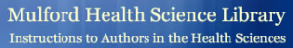

Oxford University Press - Library Resource Center (https://global.oup.com/academic/librarians/) is the central point for all OUP self-serve training materials. The Navigating Research section discusses how academic users understand, discover, and utilize reference resources. The Learn About Your Resources, Manage Your Resources and Promote Your Resources sections focus on how to effectively use the OUP resources that are available via the R4L programmes including many found in the Reference Sources menus.
Wiley-Blackwell Author Services: Contains documents to assist authors in Preparing and submitting publications plus specific Reviewers & Editors sections; material designed to assist the submission of papers to this publisher; Includes the Wiley Exchange Blog for latest tips, trends and best practices. Free Registration/Login is required.
For more resources, visit Research4Life Authorship Skills/Web Bibliography: Contains annotated links that are organized into topical sections: Multiple Topic Sites, Footnotes & Bibliographies, Intellectual Property: Copyright & Plagiarism, Publishing/Editing/Ethical Issues/Peer Review, Reading Scientific Papers, Research Resources, Submission of Research Papers & Writing Skills. Links are reviewed every 4-6 months.
Updated 2018-12
